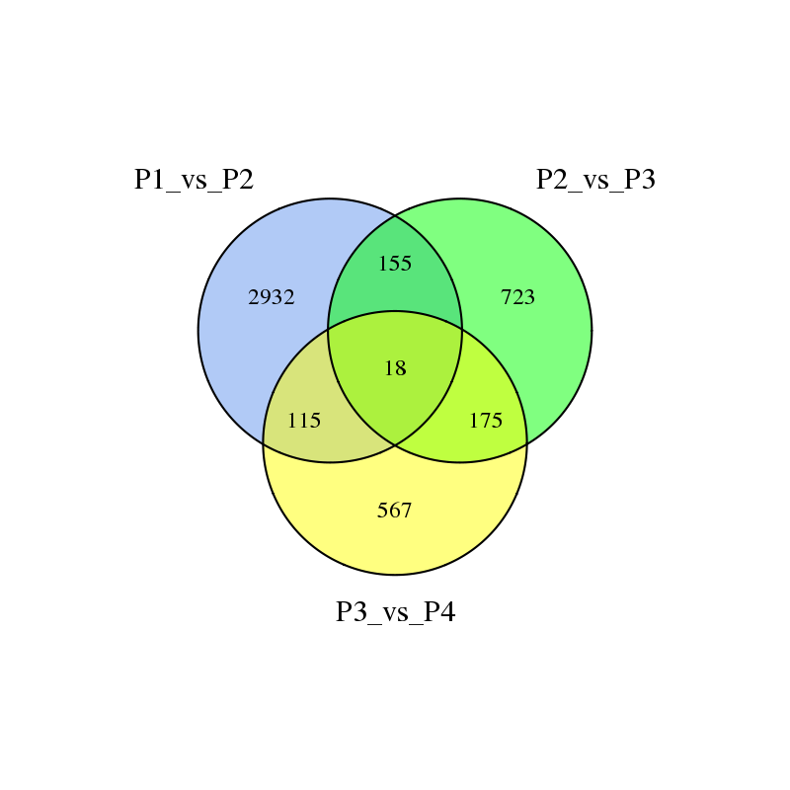

**A**

**B**

1. Venn diagram of DEGs at different stages of flower development. (B) The expression patterns of DEGs at different stages of flower development